Houghton Regis | 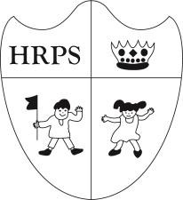 | Primary School

The end of a great term and looking forward to 2018
What a busy week it has been! Children and staff are enjoying the build up to the end of term and we have been treated to some wonderful performances this week by some of our youngest children in school.

All of our Reception pupils performed a Nativity and sang songs they had been practicing. The children confidently sang and danced their way through their production. It was incredible to see our very youngest pupils taking to the stage like ducks to water and what a journey they have made since they started in Gold Class in September. With a sea of smiles for their parents, they really enjoyed taking part and the audience was given an early Christmas treat.

The Reception Nativity was followed by an accomplished Key Stage 1 performance. Audiences were wowed with ‘A Boogie Santa’ with a vast array of characters telling the nativity story. The narrators, the stars, the angels, the farm animals, the wise men, Mary and Joseph and of course the fantastic singers all played their part in what was a great show. Once again, the children all showed how their confidence has grown this year and many took on speaking roles.

I believe that the performances we have seen this week exemplify the excellent work being done by the children and staff here at Houghton Regis Primary School. The quality of education a child receives is often judged by many solely by percentages. We are fortunate that pupil attainment and progress is rapidly improving but we are especially proud that our children develop in all other areas too. I want to thank all the parents and carers who attended this week and also the Early Years and Key Stage 1 teams for producing such lovely performances for the children to enjoy.

I’d like to thank all of the staff, governors and parents for their effort and support throughout the term, and of course our wonderful children for all their hard work too. This last full week of term has been an extremely enjoyable one.

I’d like to say a special thank you to our wonderful PTA for all of the hard work they have put in this week and across the term to raise increasingly important funds for the school. The Santa’s Grotto in school was outstanding and every child in the school enjoyed visiting Santa and his Elves. Well done to everyone involved.

Can I take this opportunity to wish you all a very Merry Christmas and a Happy New Year. I hope you all have a relaxing and enjoyable break and we will see you all in 2018 when the spring term starts for children on Wednesday 3rd January.

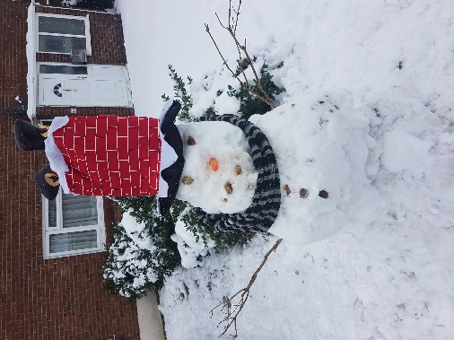
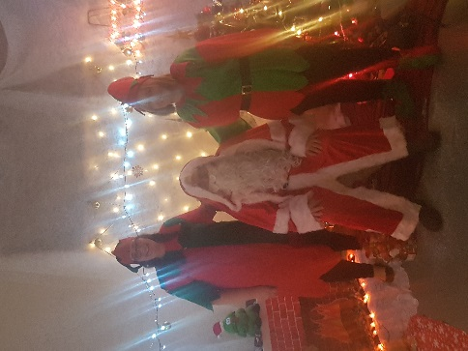
.. Other Notes
… All Parents that responded to receive a ‘present for parents’ should have received their gifts by now. We hope you all enjoy!

Thank you to all those who brought raffle tickets. This will be drawn on Monday. Good Luck to all those who participated.

This Terms Attendance:
KS1 Percentage  Gold 1 93.92%  Gold 2 93.74%  Orange 97.19%  Green 96.16%  Purple 96.75%  KS2  Blue 95.38%  Yellow 96.99%  Red 96.14%  Amber 96.47%  Sapphire 97.45% | Our overall attendance target is 97% so far only 2 out of 11 classes are on or above our target. Attendance is important for your child’s future attainment and development.  Let’s make an improvement next Term.  Well done to Sapphire and Orange class for just beating our Target keep it up!

