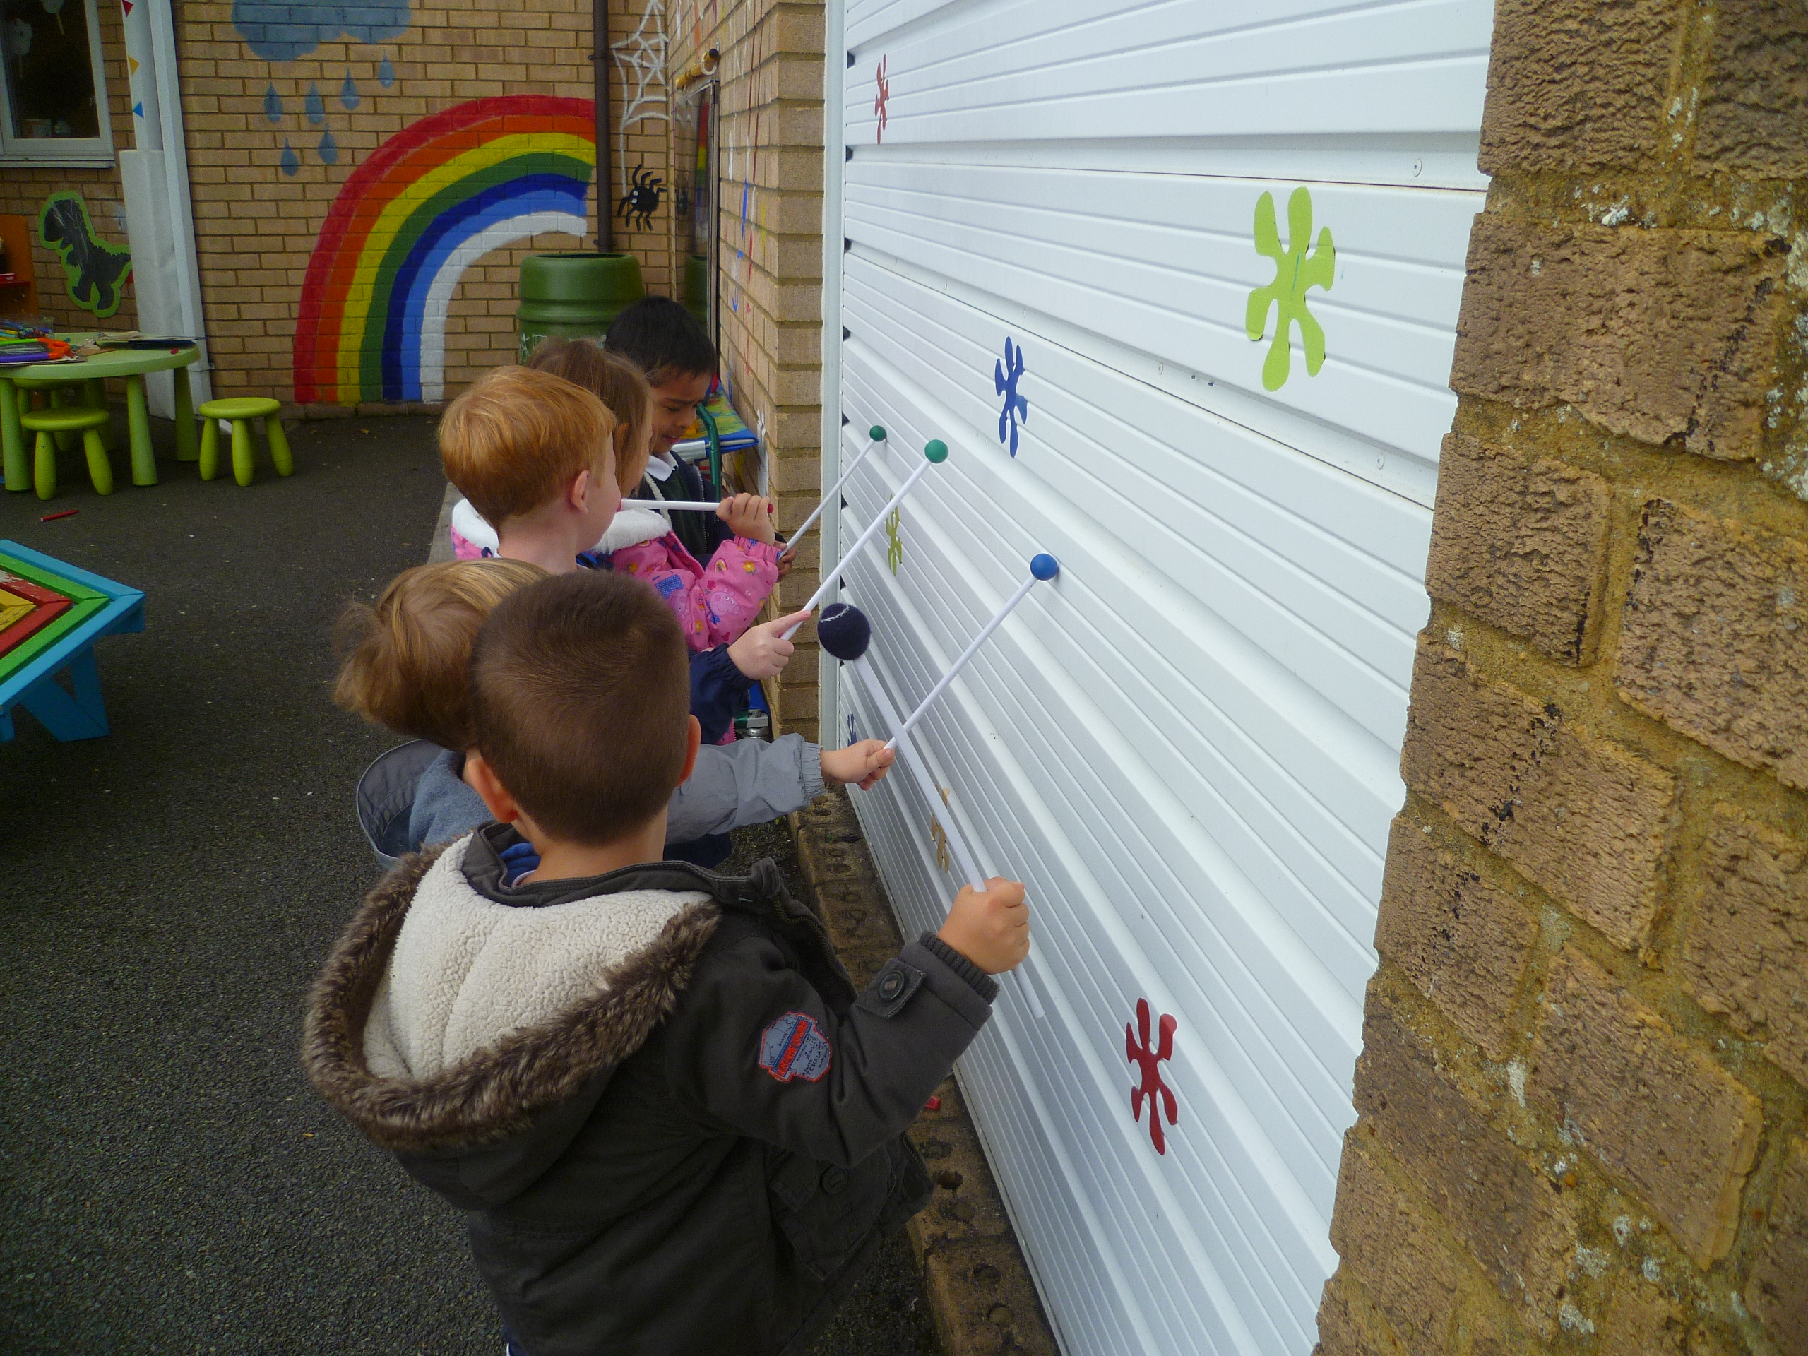
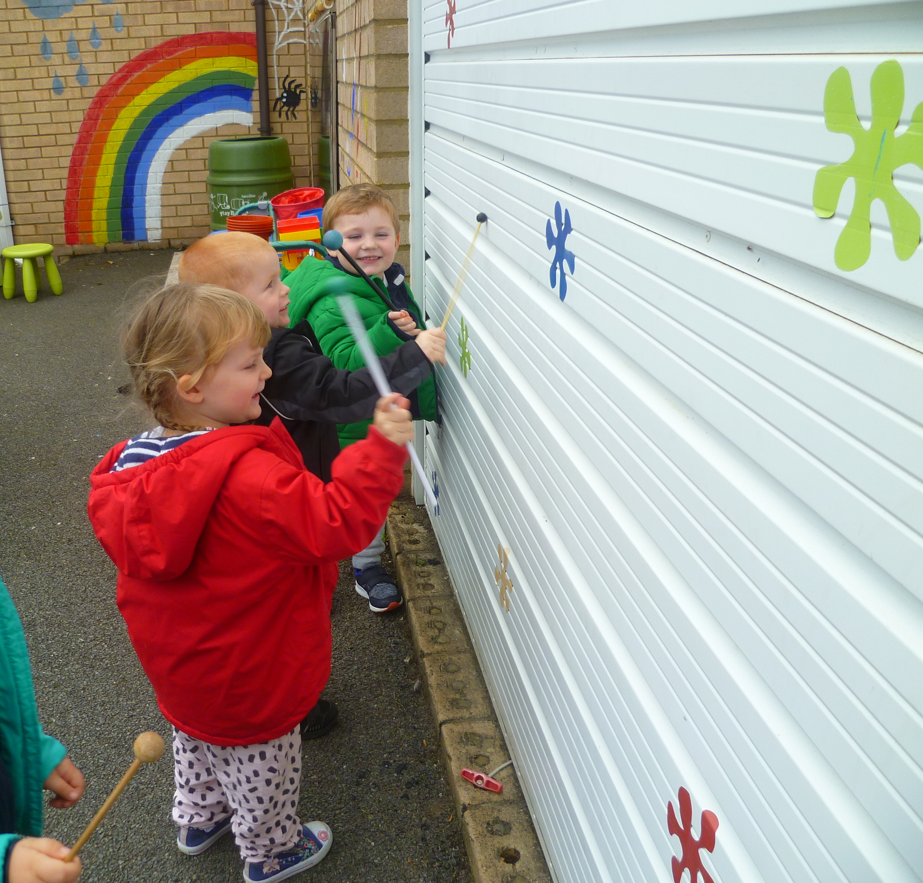
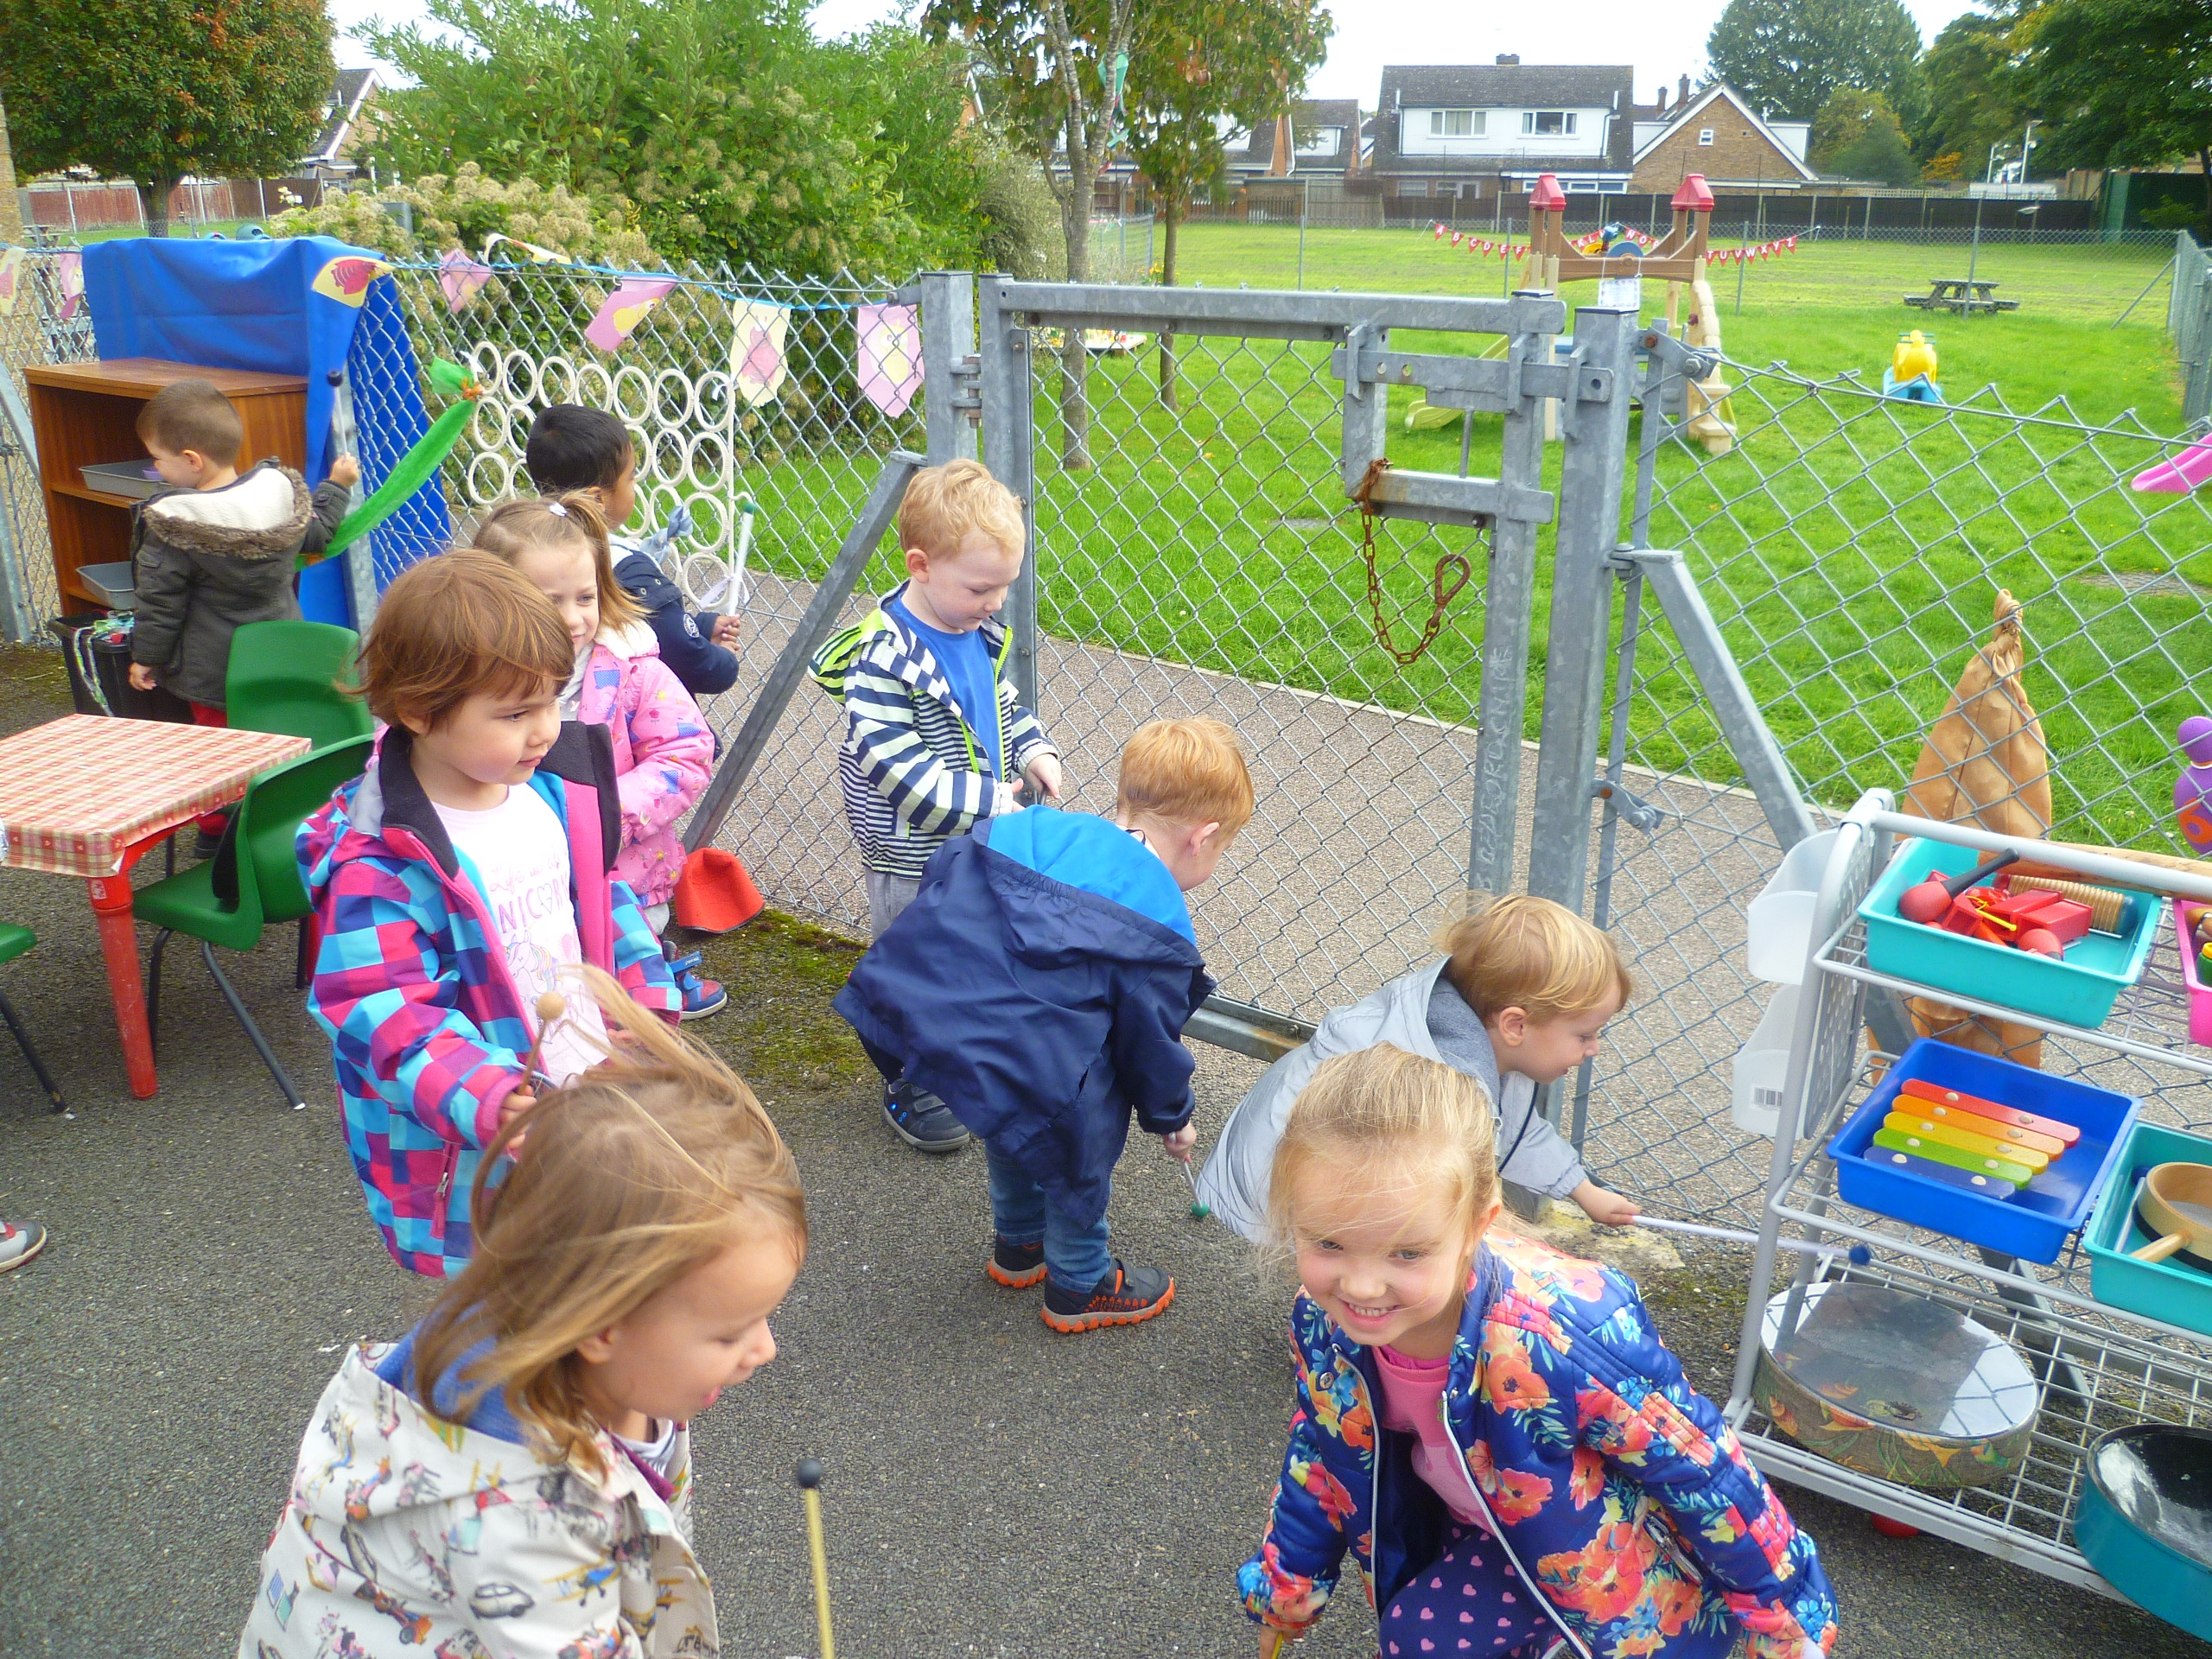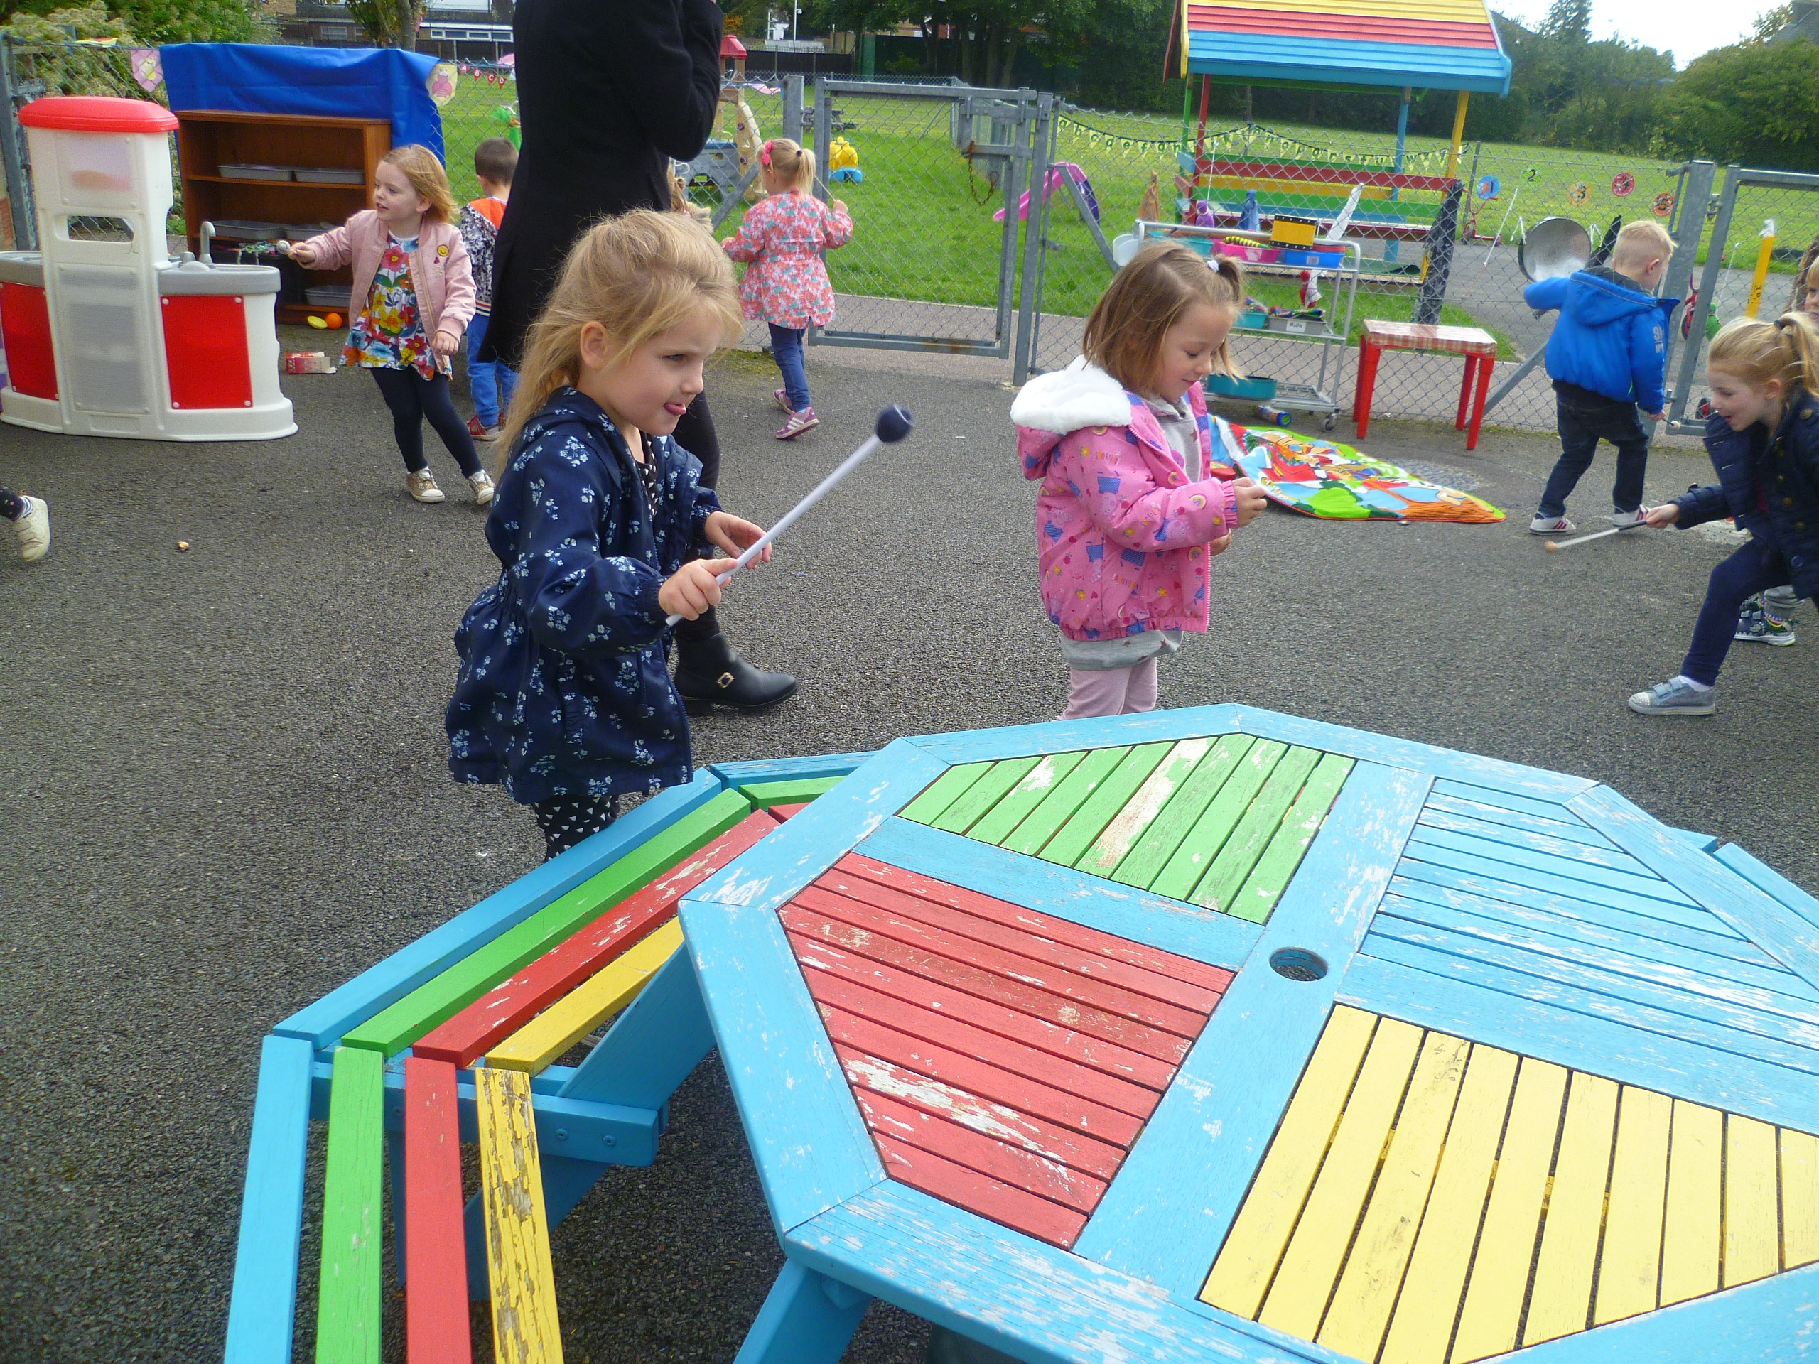
Our Listening Activities
We did a listening walk to hear the different sounds outside, some of the sounds the children could hear were the wind in the trees, an aeroplane and cars. In Silver Class the children were all given beaters to experiment with different sounds outside, tapping quietly and loudly on different surfaces. We have also enjoyed playing listening lotto games, we have had a fantastic time.

