Hi all,

Follow the link below to find our very first online outreach session from ZSL Whipsnade Zoo! This week, all about habitats.

https://youtu.be/5iItvaChEu8

We have created this especially for you as local/partner schools and learning panel members, we hope you find it useful.

Feel free to share this with teachers and parents from your school, but we would ask that you don't share this link on social media at this stage.

If you have any feedback on the session including ideas for future topics, please do get in touch!

We'd also love to see what your students create in response to our task and to have any of their questions for next week's topic - adaptations - or next week's animal - giraffes - so do email us at learning@zsl.org.

See you next week!

Holly

Holly Bestley
Senior Learning Officer | ZSL Whipsnade Zoo
Dunstable
LU6 2LF
zsl.org/education
@ZSL_Learning

If you have any issues regarding this mail please visit:
https://www.zsl.org/about-us/contact-us
Attachments area
Preview YouTube video ZSL Online Outreach - Wk 1 - Habitats
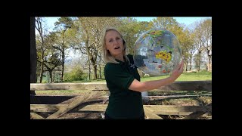
ZSL Online Outreach - Wk 1 - Habitats

