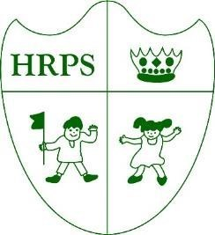
Houghton Regis Primary School

We have already raised a fair amount of money for Children in Need this Friday. The children look great in their various spotty, striped, children in need themed clothes. Thanks for the support from you all in sending your children in with their £1 donations. It has been confirmed that we have raised £292.05. Thank you!
PTA have now counted the money raised from the sponsored walk. Well done to all the children for participating and thanks to all of those that sponsored them as we have raised a fantastic £1485.80. Discussions amongst staff are taking place to see where we can best use the funds.
Year 5 went to hazard alley on 16th November. This centre teaches the children various strategies to deal with different scenarios to enable them to stay safe. It increases their knowledge on things such as fire, road, internet and personal safety.
Christmas is fast approaching and it is exciting to confirm that school Christmas dinner will take place on
Wednesday 13th December.
Just a reminder that Flu vaccinations for reception to year 4 pupils are taking places next Friday, 24th November.
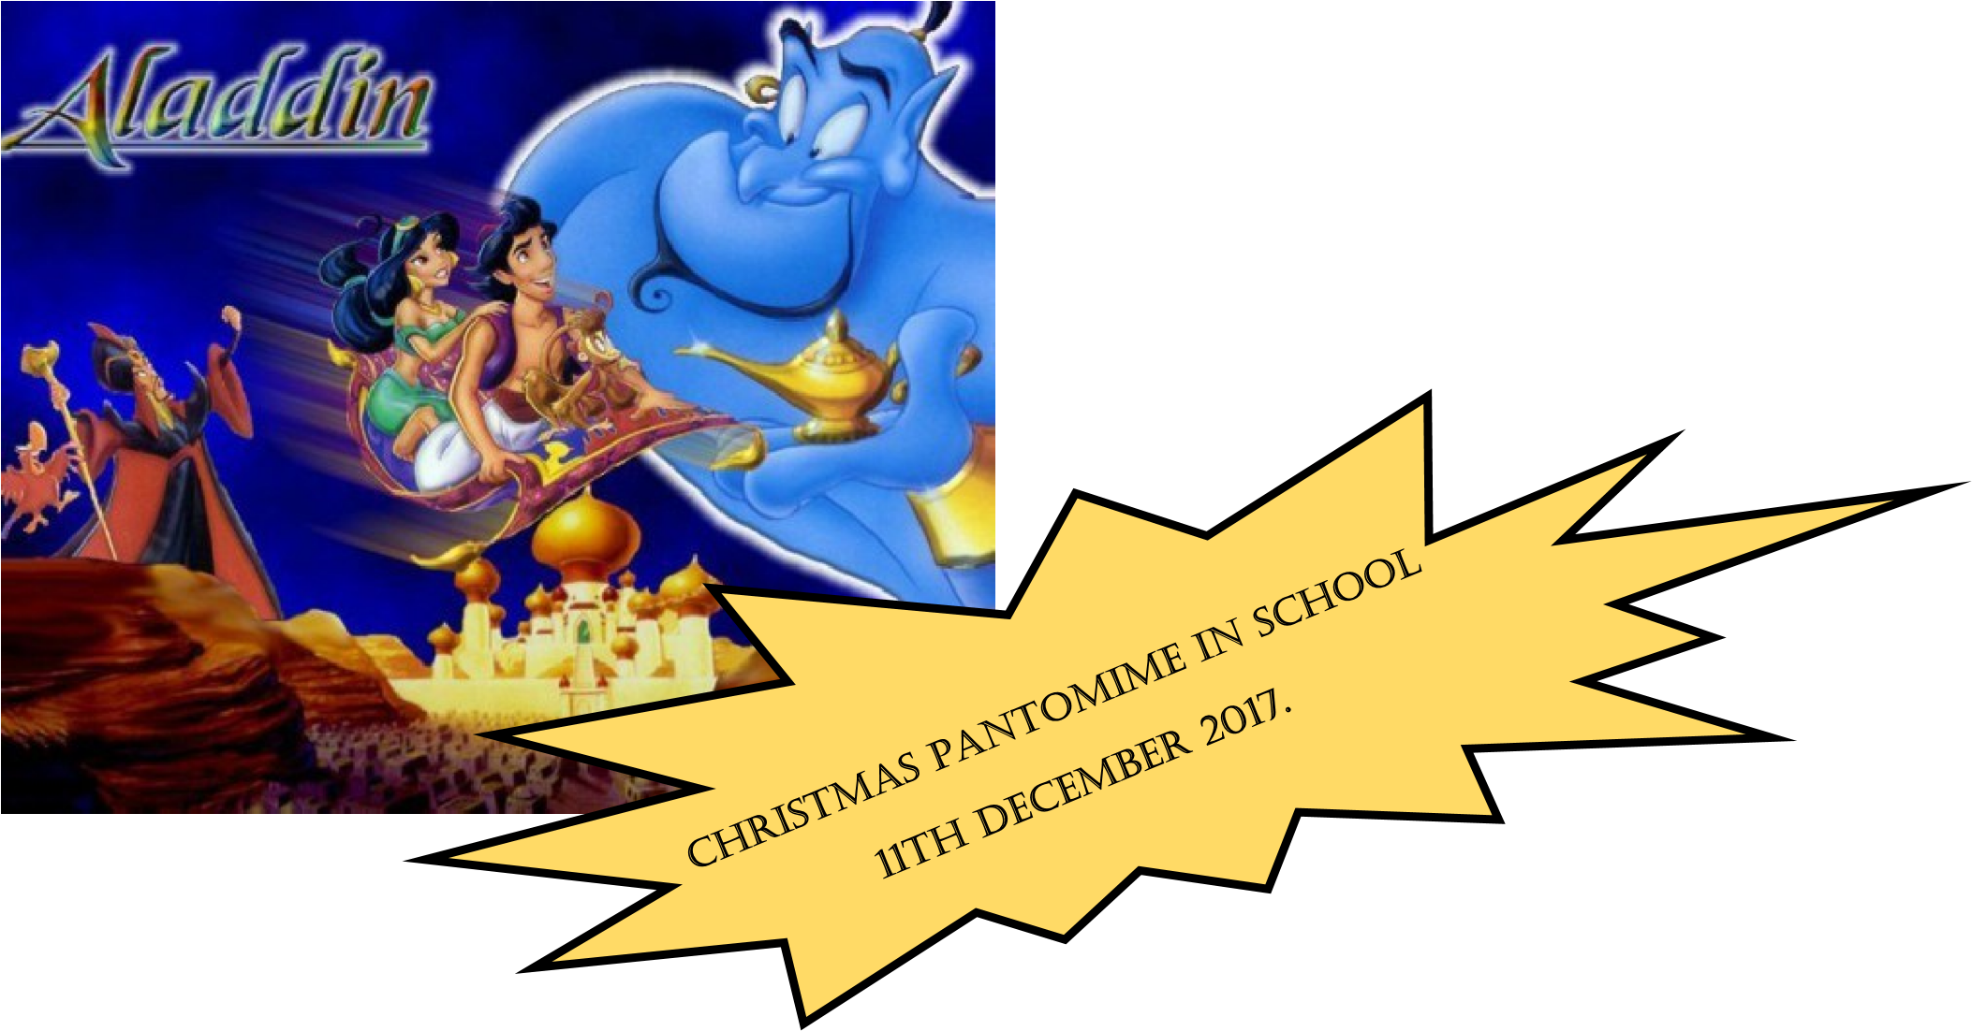
Due to the icy conditions this morning, the decision was made to close the gate that leads to the main playground as we were concerned that someone might slip and hurt themselves. Several parents ignored the notice that was put up and were verbally abusive to our site agents, who for health and safety reasons was attempting to close the gate.
Please note any form of abusive behaviour to any member of our staff is not acceptable, and will not be tolerated. Now that winter is upon us please respect that we may have to make the decision to close areas of the school grounds for health and safety reasons without the opportunity to give for warning.

The overall attendance for this week is
97.58
%. Fantastic
!

KS1

Gold 1

98.31
%

Gold 2 98.30%

Orange 98.87%

Green 99.60%

Purple 96.28%

KS2

Blue 97.39%

Yellow 95.63%

Red 94.96%

Amber 100%

Emerald 96.32%

Sapphire 98.45%

The attendance bear is going to Amber
with 100% attendance this week. Well
Done!

Our attendance target is
97
%.

Well done to everyone we
are above our attendance
target this week with
97.58
%.

Attendance is important
for academic progress and
personal development.

Date | Event
24/11/17 | Flu Vaccinations R- Year 4b
28/11/17 | KS1 and Gold Assembly – Science ‘Water’ KS2 Assembly science ‘Water’
29/11/17 | Internet Safety Police Presentation for years 3 and 4 2pm3pm
30/11/17 | Amber Parent Assembly 2.30pm
5/12/17 | Year 6 trip to British Library  E-safety workshop for parents 9am
6/11/17 | Silver Admissions Afternoon 2.15-3pm
7/12/17 | Emerald Assembly 2.30pm
8/11/17 | Reception – Vision Screening 9.30am
11/12/17 | Aladdin pantomime in school
13/12/17 | Gold Nativity 9.15 am
14/12/17 | Year 1 and 2 Xmas production 2pm and 6pm  Street Dance Final session and performance to parents
15/12/17 | Christmas Discos
19/12/17 | Last day of term

Dear parent/carer(s),

On the 13th and 14th December Gold class, year 1 and year 2 will be holding their Christmas productions. During this time year 6 would like to sell refreshments, sweets and raffle tickets to raise money for their junior prom and other events next year.
In order for year 6 to do this we would like to ask for donations of sweets by Thursday 23rd November.
We would also like donations of any unwanted gifts, toiletries or anything you feel that can be raffled. These can be bought into school from Monday 20th November.

We would like to thank you for your continued support.

Year 6

