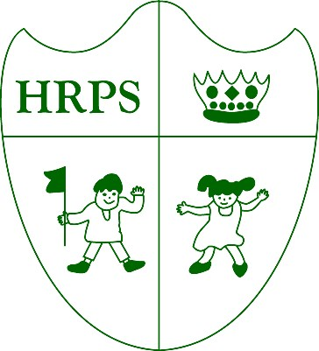
Houghton Regis Primary School

“Where everyone matters and every day counts”.
We still have another busy week ahead of us before half-term is here: a few notices and celebrations are to be shared.
Firstly, our school is working hard towards being environmentally friendly. The development of our Eco-Committee has led to our Eco-Warriors achieving the internationally recognised Bronze award from Eco schools; they have set up a committee, completed an environmental review and drawn up an action plan. They are now very close to achieving Silver!
It was lovely to see so many parents, carers and friends at school to watch Blue class’ wonderful assembly on The Romans– it was excellent!
On Wednesday pupils completed their ‘Sponsored Walk’ around the school premises to raise funds for additional, exciting resources. We will notify you how much was raised once figures are confirmed. We look forward to using the sponsorships to further enhance your children’s learning and school experience.
A massive thank-you to all those parents and staff members who came in on Sunday 8th October to tidy our school grounds. Another day devoted to this will soon be pencilled in– any voluntary helpers would be greatly appreciated. Please also note that if you are interested in joining our PTA information is available from the school office.
Finally, we would like to welcome Mrs Peklivanas a new, additional member to the office to our school team.

A reminder that Parents
Evenings are taking place
next week
–

17
th Oct
3.30
-
6
pm

19
th Oct 5pm
-
8
pm.

Harvest Festival Assembly 18/10/17.

Any donations of non
-
Perishable gifts
Would be appreciated!

Any gifts can be brought in on

Tuesday 17th Oct.

 | This overall attendance for week ending  Gold 1 96.39%  Gold 2 92.39%  Orange 99.23%  Green 99.00% Purple  KS2  Blue 96.86%  Yellow 94.64%  Red 99.63%  Amber 99.00%  Emerald 99.41%  Sapphire 96.33%  The Attendance Teddy will go to Purple class who have got 100% attendance. Fantastic! |  | 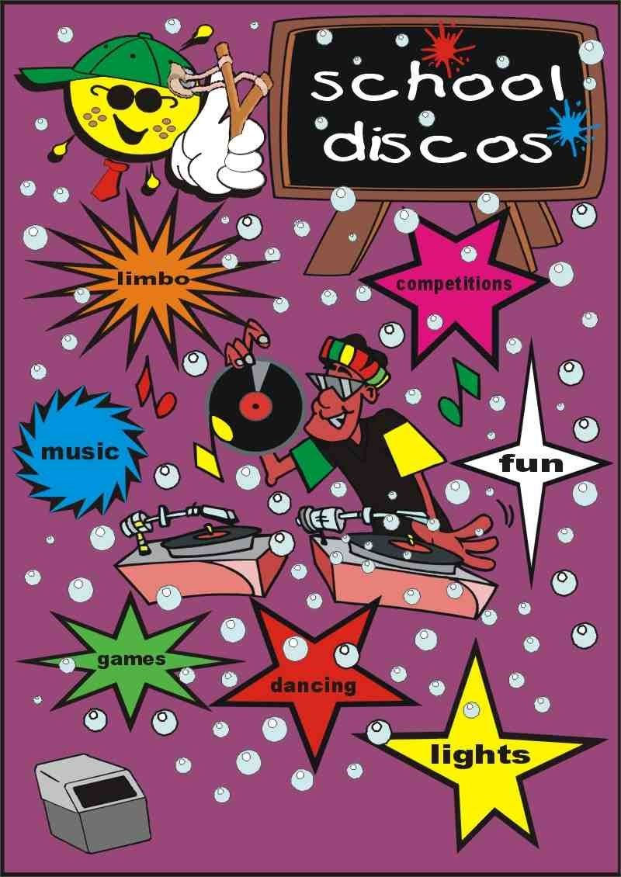  We are currently above our  target of 97%, lets keep it up.  Attendance is extremely  important for pupils personal  and academic growth.  School Disco’s are  taking place on Friday  November 3rd in two  sessions. One is held for  KS1 and the other KS2.  Unfortunately places  are limited to 100  children per session due  to health and  safety regulations.  Tickets will be granted  on a first come first  serve basis.
Date |  | Event
17/10/17 |  | Parent’s evening 3.30-6.30pm
18/10/17 |  | Wow Wednesday Silver  Harvest Festival Assembly
19/10/17 |  | Parent’s Evening 5-8pm
20/10/17 |  | Last Day Of Term
11/12/17 |  | Aladdin pantomime in school

