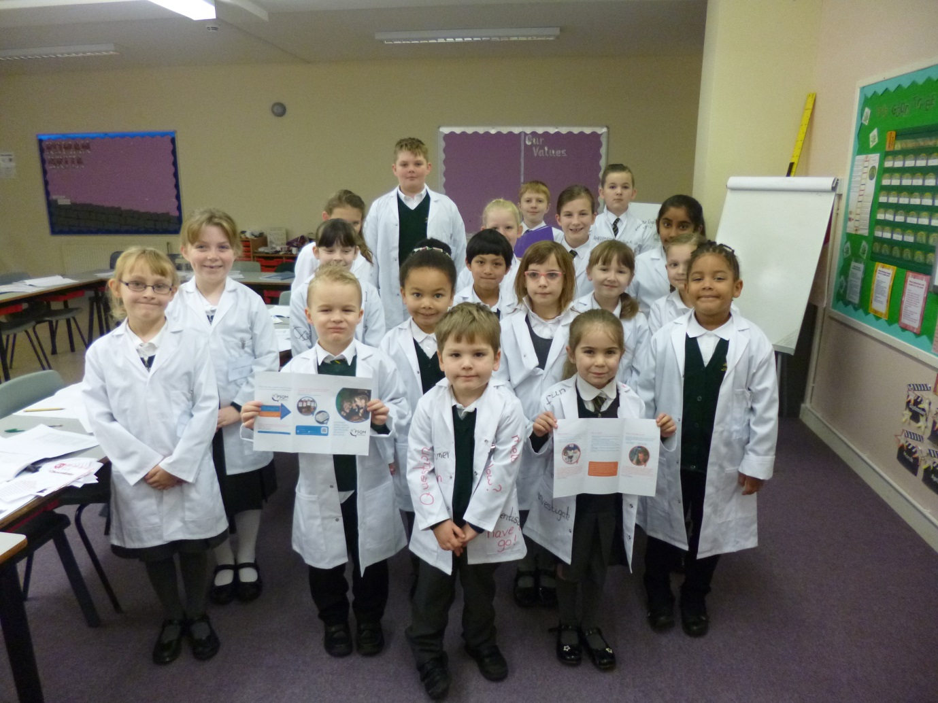
SCIENCE AMBASSADORS 2017/18

The science ambassadors’ role. The science ambassadors wear their lab coats whenever science is taking place. They may have a special report card to complete, detailing the lesson and identifying learning that has taken place. The younger children can record by taking photographs and, at our science ambassador meetings; they all discuss what learning is taking place. All this evidence will go towards our Primary Science Quality Mark (PSQM) which we are hoping to achieve this year.

