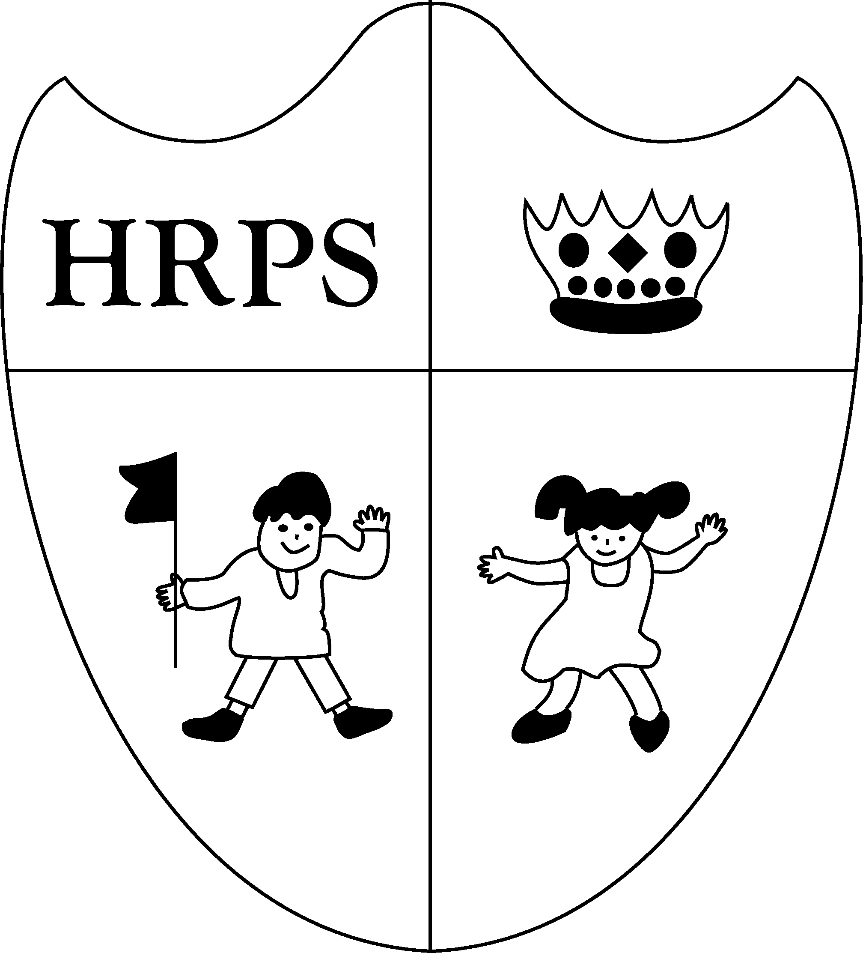
Houghton Regis Primary School PE kit policy 2018/19
At Houghton Regis Primary School, we recognise the importance of Physical Education and not only how this physically impacts the children of our school but how it also engages them in understanding how to maintain a healthy, hygienic lifestyle.
It is vital that all children understand the need to change clothing in preparation for physical activity and support their learning. We also feel a school PE kit gives each child a sense of belonging to our school.
All children should bring their PE kit to class even if they are not going to be actively involved as a performer. If a child is injured or unwell, a signed note from the parent or carer must be provided to the class teacher / coach in advance of the lesson. Children who are excused will still need to change into their PE kit as they will be involved in the learning process through the role of a coach, umpire, referee or leader.
Please note that no jewellery is to be worn during PE lessons and must be removed by the child themselves. We would strongly advise for piercings to be completed during school holiday periods to allow healing time. If piercings are not healed, it will be the responsibility of the parent / carer and or the child to supply and apply plasters to cover such piercings.
Long hair must be tied back in order to prevent entanglement in apparatus and to prevent it obscuring vision.
Houghton Regis Primary School PE kit list:
Indoor / summer PE kit
Black shorts
Jade green t-shirt
Winter / outdoor PE kit
Plain black track suit bottoms and a track suit jumper / zipped jacket. (Please note hoodies are not to be worn).
Or black shorts with black football / hockey socks
Please note a plain base layer / long sleeve top may be worn underneath the Jade green t-shirt as an additional layer (ideally- black, white or grey).
Dependent on the activity children may wish to wear shin pads. Additional clothing in the winter such as gloves can be worn by the children if the class teacher/ coach think it is necessary
Footwear
All children should have suitable footwear for both indoor and outdoor PE lessons. Indoor lessons will require either bare feet or plimsolls. Outdoor lessons will require comfortable, supportive trainers; in some cases football boots may be worn, but again this will be advised by the class teacher / coach if necessary.
All PE kit items are to be brought into school in a named drawstring bag that can be hung on the child’s peg.

