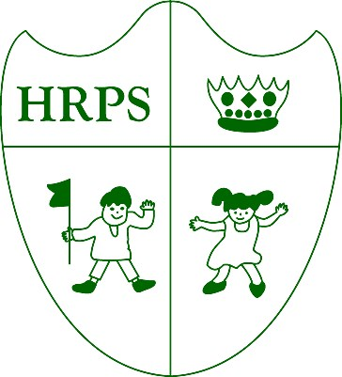
Houghton Regis Primary School

“Where everyone matters and every day counts”.
This week was another busy one for us Houghton Regis Primary School we have had a variety of things taking place.

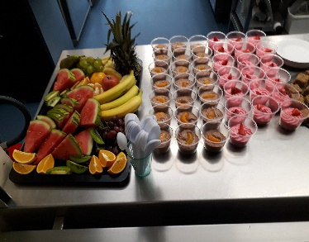
Thank you to all the parents who made it to our two Parent’s Evenings. Our Kitchen staff had a selection of delightful dishes that are now served at the school for parents and children to try. There are a variety of options for children at lunch time and this alternates every week on a three-week rotation. All Key Stage 1 children are entitled to free school meals and the cost from Year 3 onwards is only £2.00 per meal. The menu can be viewed on our website.
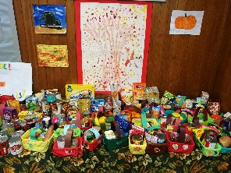
Thank-you to all those that donated non-perishable items for Harvest Festival. We received a huge amount with some children even painting and drawing pictures that will be given out.

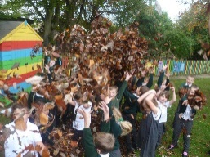
Some of our KS1 children took a walk down to Houghton Hall during their Literacy lesson to explore autumn leaves. They talked about what they looked like, sounded like and how they felt using nouns, verbs and adjectives to write an evocative Autumn poem.
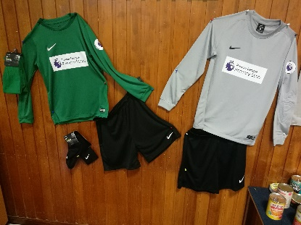

This week we have been fortunate enough to win a full team football strip from the Premier League in our school colours. The strip along with the goalkeepers strip was on display in the hall during the two parent’s evenings that were held this week. We are hugely grateful to the Premier League for choosing our school to receive this fantastic surprise.

All Disco tickets should have been received by your children over the past few weeks. Please keep these safe and bring them with you on Friday 3rd November.

Next half tem we say goodbye to Mrs Game is going onto pastures new outside of education – We wish her all the very best for her future.

Mrs Reed has some exciting news for you all - We are pleased to announce that Mrs Reed is expecting her first child next Spring.

We hope you all have a lovely break and will see you on Monday 30th October.

The overall attendance for week ending 20th October is 95.47%  Gold 1 92.31%  Gold 2 93.60%  Orange 98.04%  Green 96.30%  Purple 93.66%  KS2  Blue 95.24%  Yellow 94.86%  Red 97.61%  Amber 93.92%  Emerald 98.04%  Sapphire 96.67%  The Attendance Teddy will go to both Orange and Emerald class with the attendance of 98.04%! |  | We have fallen below our 97% target. Attendance is important for pupil’s progression and life skills.
Date | Event
3/11/17 | Disco 1 and 2

