Houghton Regis Primary School September 2014

Behaviour Policy
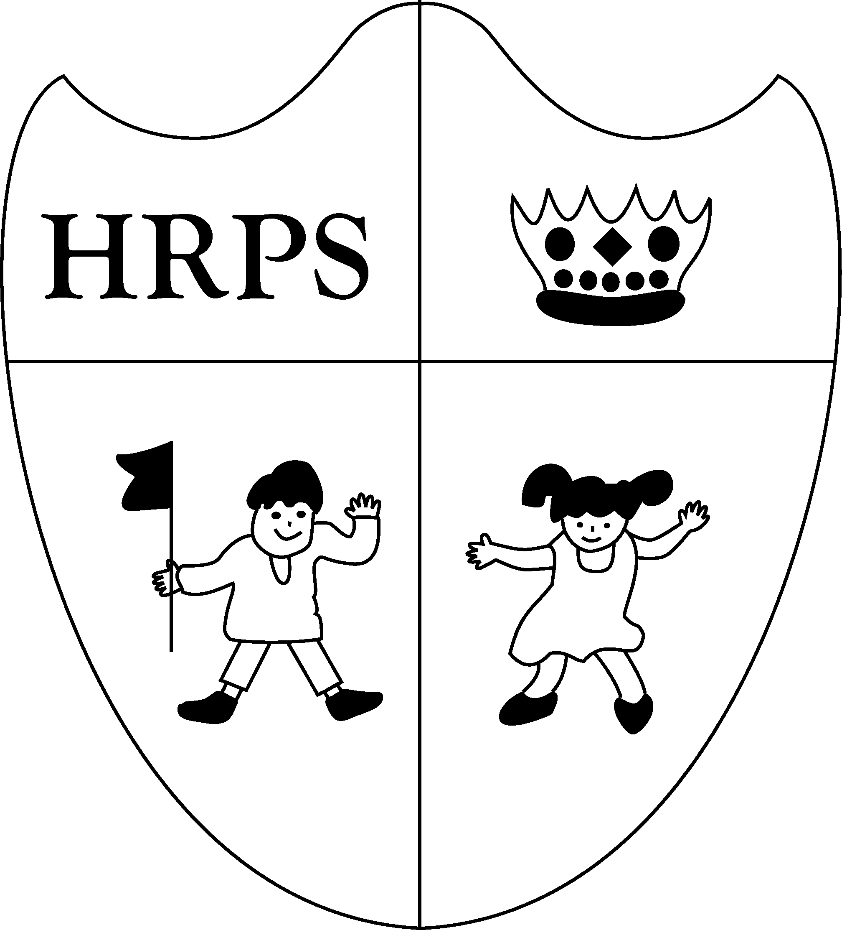

Rationale

We believe that positive pupil behaviour is a whole school issue and is the shared responsibility of all staff who work in our school. We believe that good behaviour is a fundamental element of being a happy and successful school. We believe that parents must also share this responsibility and that co-operation between staff and parents is essential in promoting good behaviour.
The promotion of the values of mutual respect, self-discipline and social responsibility which underline good behaviour is taught through example, class discussion, stories, assemblies etc.

The policy adopted and followed by Houghton Regis Primary School is Positive Assertive Discipline.
The policy provides for consistency of approach, for all parties, in dealing with matters of school discipline and in the promotion of good behaviour.

Aims

In our school we expect children to: -
- observe the rules throughout the school.
- behave courteously and with consideration towards others in the school whatever their status.
- treat the school environment with respect, both inside and out, keeping it tidy and litter free.
- take responsibility for their own actions.
- be able to apply self-discipline in a variety of situations.
The children will learn that there are clear expectations of their behaviour in the classroom.
Rules will be established and discussed and the children will understand the consequences if they choose to break the rules. These rules will be constantly reinforced. There will also be a strong element of positive reward in the discipline plan. This reward will focus on a great deal of praise and there will be other positive outcomes such as certificates, stickers, letters home and whole class treats.
The aim of the behaviour plan is to create a positive calm consistent atmosphere that will lead to a more responsible independent response from the children. This in turn will build confidence and self -esteem leading to enhanced learning.

Success criteria

- Positive classroom behaviour observed by all.
- Positive behaviour around the school environment.
- Positive behaviour on school trips outside the school environment.
- Certificates awarded and acknowledged.
- Visitors observe positive behaviour.
- All staff take responsibility for monitoring the behaviour and responses of all children.
- Pupils feel safe and secure.
- Pupils express positive feelings about school.
- Pupils develop in self-confidence and have positive self-esteem.
- Pupils co-operate with staff and peers.
- Home/school co-operation.
- Parents attend meetings within the school environment.
- Parents notice pupil behaviour and reward systems and reinforce school policy at home.
- School environment is kept clean and tidy.
- Children seen helping other children.
- Pupils attain positive reports and achieve incentives.
- Pupils interact and play positively during break times.
- Classroom whiteboards in use.
- Pupils display good manners at all times.
- Other schools comment on positive behaviour of our pupils.

