**ORANGE CLASS (Year 1)**

We made clay aliens, alien spaceships and symmetrical aliens.

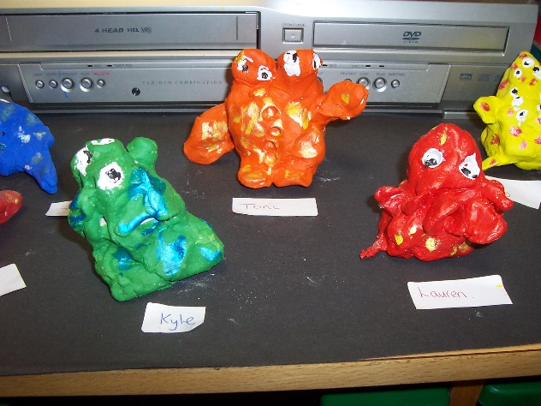 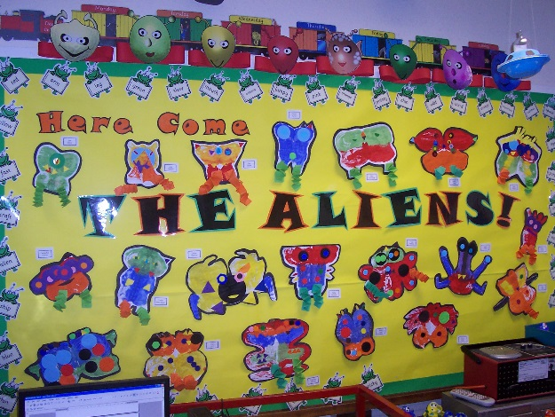

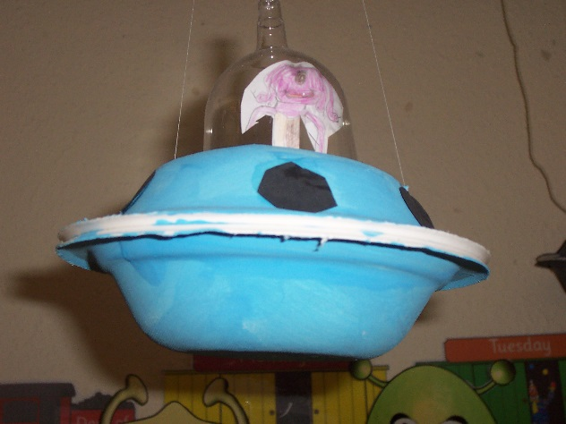

We used ‘Flying Colours’ to draw symmetrical aliens in the ICT room.

